# LAW & ORDER: SPECIAL VICTIMS UNIT Boss: ORGANIZED CRIME Delay Also Pushes Back Benson-Stabler Reunion

August 27, 2020 by [Marisa Roffman](https://www.givememyremote.com/remote/author/marisa/)

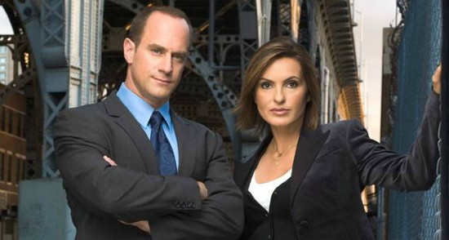

***Credit: NBC***

With NBC [shaking up its fall schedule](https://www.givememyremote.com/remote/2020/06/16/nbc-2020-2021-schedule/) and [moving the LAW & ORDER: SPECIAL VICTIMS UNIT spinoff LAW & ORDER: ORGANIZED CRIME to midseason](https://www.givememyremote.com/remote/2020/08/27/nbc-fall-2020-premiere-dates/), that also impacts the plans for [SVU’s season premiere](https://www.givememyremote.com/remote/2020/05/01/elliot-stabler-return-svu-22-premiere-spoilers-squadroom-interview/).

Originally, SVU’s season 22 opener would have had to contend with reintroducing [Christopher Meloni’s Elliot Stabler](https://www.givememyremote.com/remote/2020/07/07/law-and-order-organized-crime-chris-meloni-benson-stabler-reunion/), who has been absent from the series since 2011 and is leading up ORGANIZED CRIME. (This was, of course, after the plans had to be scrapped—due to COVID-19 shutting down production—to [bring his family into the season 21 finale prior to Stabler’s return](https://www.givememyremote.com/remote/2020/05/01/elliot-stabler-return-svu-22-premiere-spoilers-squadroom-interview/).)

“It’s pretty clear that Elliot will be in SVU season opener,” SVU boss [Warren Leight teased earlier this year](https://www.givememyremote.com/remote/2020/05/01/elliot-stabler-return-svu-22-premiere-spoilers-squadroom-interview/) on the show’s official podcast. “I think that much I know. Whether we get to see his family, as well, remains to be seen. There’s a lot of moving parts. They’re launching a new series, as well. It’s not just about the SVU season opener, it’s how [do we help launch the new series](https://www.givememyremote.com/remote/2020/07/07/law-and-order-organized-crime-chris-meloni-benson-stabler-reunion/), and [how much crossover will there be between Elliot and Olivia](https://www.givememyremote.com/remote/2020/07/30/law-and-order-organized-crime-questions-season-1/) as it goes on.”

But with SVU returning in November and ORGANIZED CRIME’s launch not coming until 2021, Stabler *won’t* be in the premiere…at least as of now.

“These days all plans are subject to change,” [Leight told a fan on Twitter](https://twitter.com/warrenleightTV/status/1299079009553260558). “And then they change again. And again. For now, we won’t reintroduce Stabler until the night of his Organized Crime premiere. [@SVUWritersRoom](https://twitter.com/SVUWritersRoom) has to be NIMBLE this year.”

***LAW & ORDER: SPECIAL VICTIMS UNIT, Season Premiere, Thursday, November 12, 9/8c, NBC***

***LAW & ORDER: ORGANIZED CRIME, Midseason, NBC***